PWA video 15 pre caching assets

<https://www.youtube.com/watch?v=kT3qSf7jG5c>

What do we need to cashe – the App Shell -core static assets that make up the basics of the app

Like a logo, index page , core css style sheets.

<https://developers.google.com/web/fundamentals/architecture/app-shell>

A good place to do this is inside the SW install event handler – since this happens everytime a SW file changes and we reload the page. So just when the sw changes, like we update the app. The assets being cashed don’t change much

caches is the api

In this code if the staticCacheName exits open it, if not create it and open it

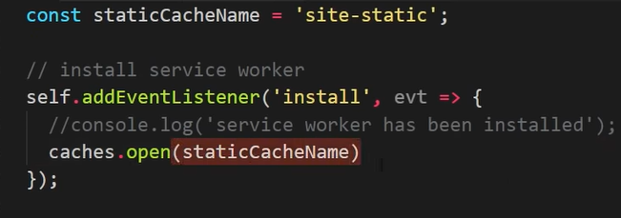

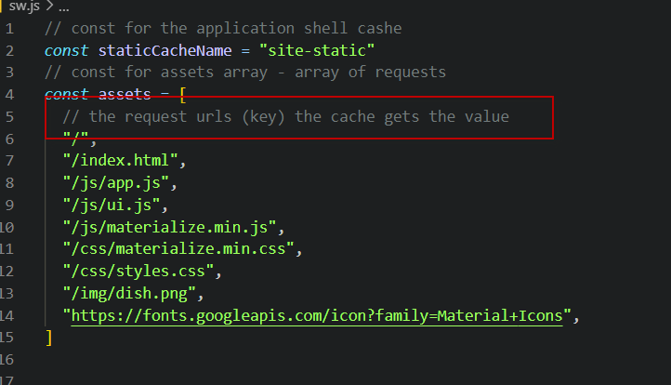

Now n cache

